DAY 24_Ride Booking Analysis
You are working as a data analyst for a ride-booking company like Ola/Uber.
Each ride record is stored as a tuple: (ride_id, driver_name, city, fare, rating)
Sample Data:
rides = (
(101, "Ravi", "Bangalore", 250, 4.5),
(102, "Anjali", "Hyderabad", 180, 4.2),
(103, "Kiran", "Bangalore", 300, 4.8),
(104, "Meena", "Chennai", 220, 4.0),
(105, "Arjun", "Bangalore", 150, 3.9)
)
Tasks
Count total rides
Find how many ride records are present.
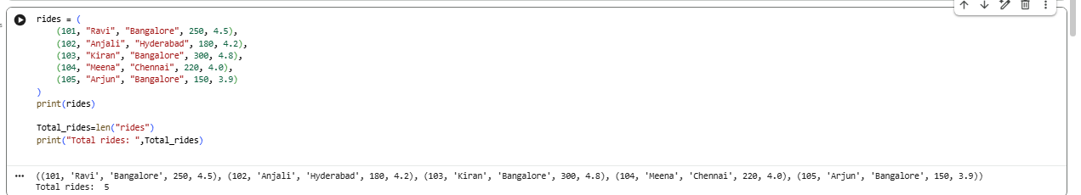
Extract all rides from Bangalore
Print only tuples where city = "Bangalore"
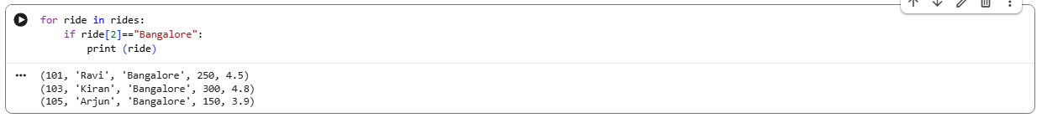
Find total revenue from Bangalore
Sum of fares where city is Bangalore
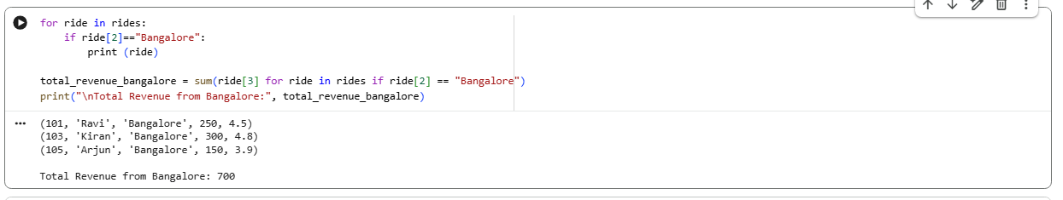
Find highest rated driver
Print the tuple with maximum rating
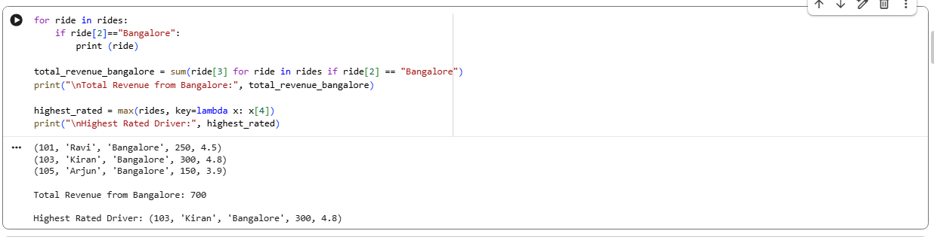
Average rating per city

Output should look like:
{
"Bangalore": 4.4,
"Hyderabad": 4.2,
"Chennai": 4.0
}

